Structural and Behavioural Model
System Name: QueueSmart – Digital Waiting System for Hospital Outpatient Services
by
Naga Sai Bolla

1. Use Case Diagram
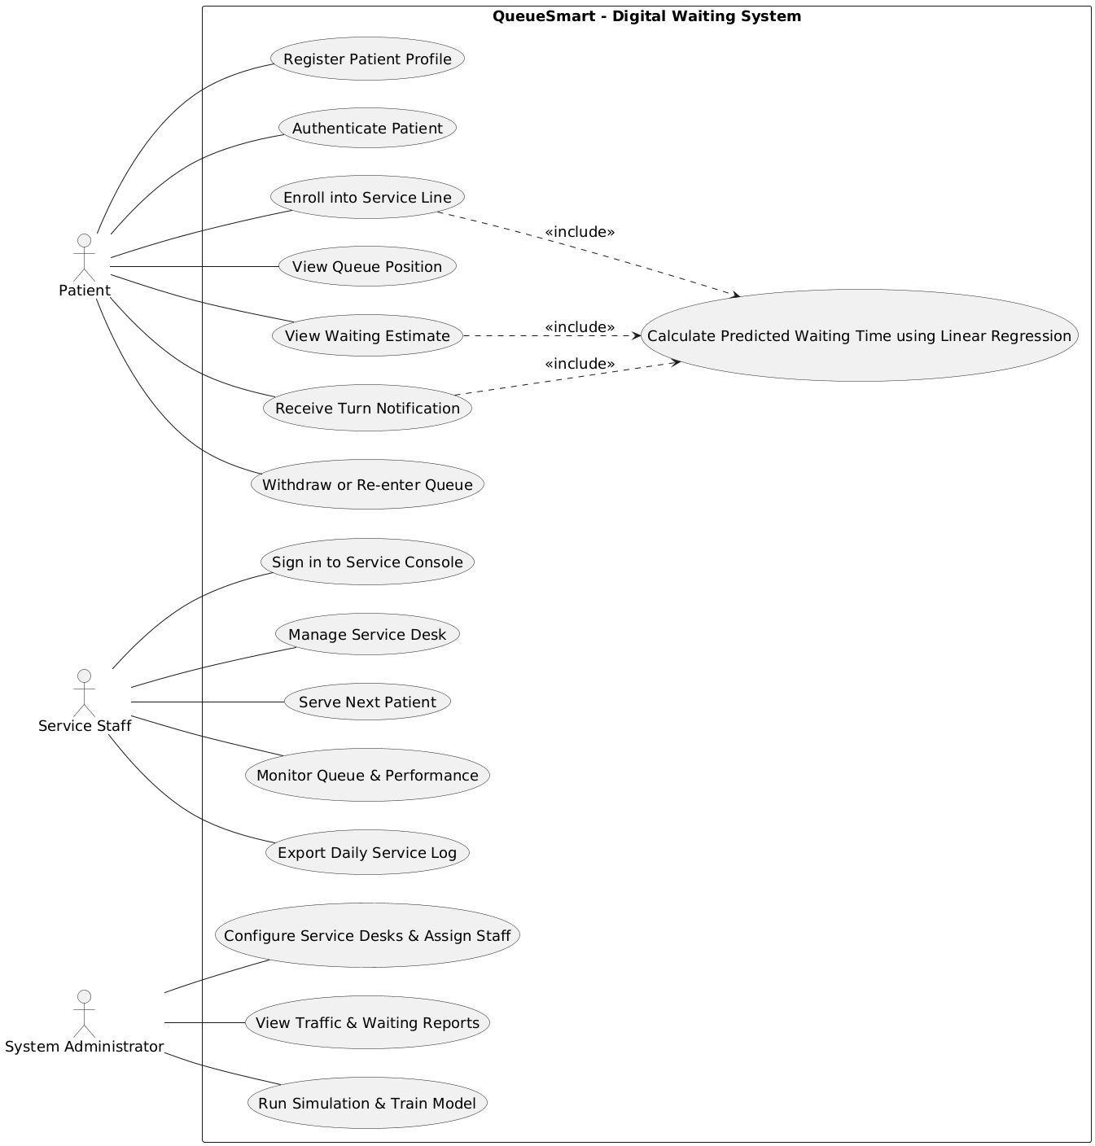Figure.1 Use Case Diagram

2. Class Diagram
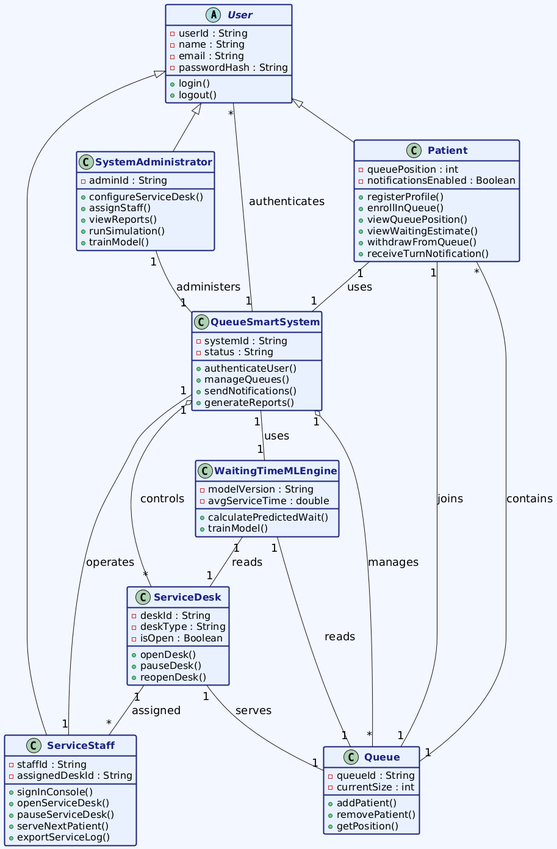
Figure.2 Class Diagram

3. Object Diagram
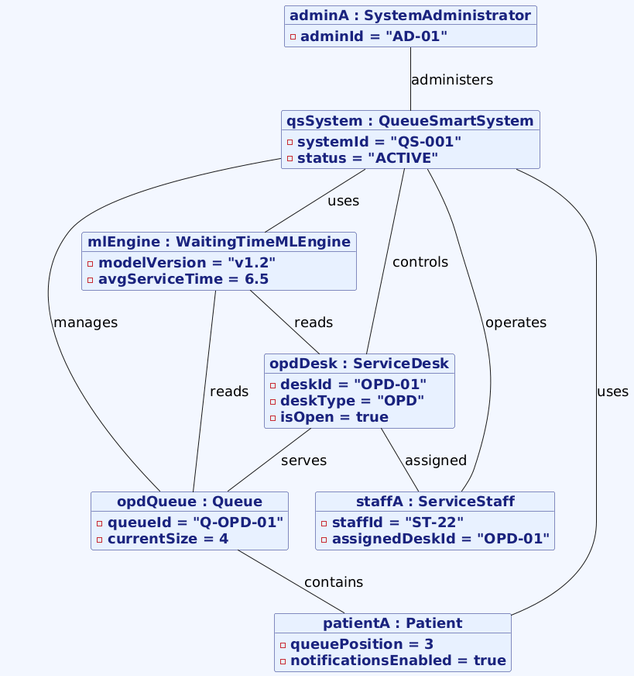
Figure.3 Object Diagram

4. Sequence Diagram
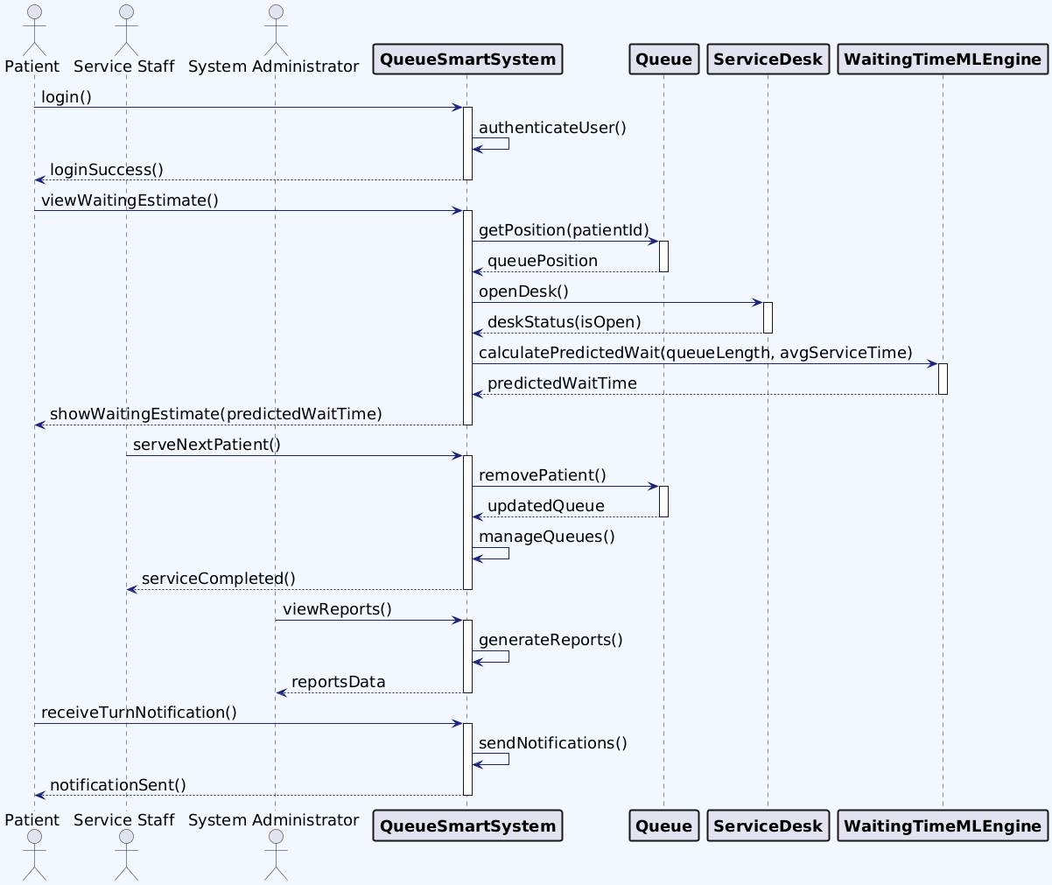
Figure.4 Sequence Diagram

5. Behavioural state machine diagram
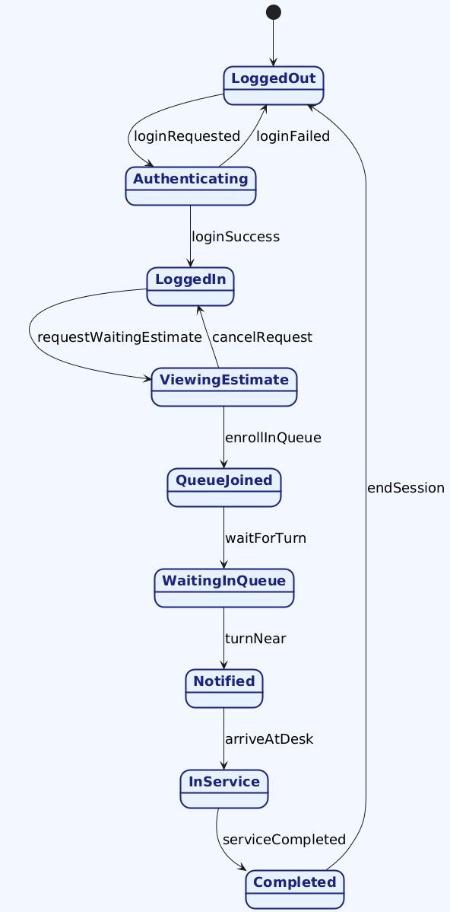
Figure.5 State Machine Diagram
6. Traceability table: Mapping (Use cases, Structural, and behavioural Model)
The functional model described the main tasks the system must support and how users interact with it. These tasks were reviewed to identify the key parts of the system, such as patients, staff, service desks, queues, and the main system. These parts were then used to build the class diagram and define how they are linked. The behavioral models were created from the same tasks to show how the system works during real use. The sequence and state diagrams show how actions happen step by step when a patient logs in, checks waiting time, joins a queue, and receives service. This method keeps all models aligned and meaningful.
Traceability Table: Use Cases to Classes Mapping
Use Case No. | Use Case Name | Classes Used
1 | Register Patient Profile | Patient, QueueSmartSystem
2 | Authenticate Patient | User, QueueSmartSystem
3 | Enroll into Service Line | Patient, Queue, QueueSmartSystem
4 | View Queue Position | Patient, Queue
5 | View Waiting Estimate | Patient, WaitingTimeMLEngine, QueueSmartSystem
6 | Receive Turn Notification | Patient, QueueSmartSystem
7 | Withdraw or Re-enter Queue | Patient, Queue
8 | Sign in to Service Console | ServiceStaff, QueueSmartSystem
9 | Manage Service Desk | ServiceStaff, ServiceDesk, QueueSmartSystem
10 | Serve Next Patient | ServiceStaff, Queue, ServiceDesk
11 | Monitor Queue and Performance | ServiceStaff, QueueSmartSystem
12 | Export Daily Service Log | ServiceStaff, QueueSmartSystem
13 | Configure Service Desks and Assign Staff | SystemAdministrator, ServiceDesk, QueueSmartSystem
14 | View Traffic and Waiting Reports | SystemAdministrator, QueueSmartSystem
15 | Run Simulation and Train Model | SystemAdministrator, WaitingTimeMLEngine, QueueSmartSystem
16 | Calculate Predicted Waiting Time | WaitingTimeMLEngine, Queue, ServiceDesk

